|  |  |
| --- | --- |
|  | *Shahid Smarak College* |

*Kathmandu, kirtipur – 10*

Submitted by: -

Shrijal Maharjan

BCA 3rd Semester

Submitted to: -

Himal Raj Gentil.

Lab 1

Program Code of Implementation of Stack.

#include<stdio.h>

#include<conio.h>

void push();

void pop();

void display();

int tos=-1,stack[5],max=5;

void main()

{

int ch;

clrscr();

top:

printf("\nInput the choice");

printf("\n1 to PUSH data in the stack");

printf("\n2 to POP the data from the stack");

printf("\n3 to display data");

printf("\n4 to exit");

scanf("%d",&ch);

switch(ch)

{

case 1:

push();

goto top;

case 2:

pop();

goto top;

case 3:

display();

goto top;

case 4:

exit(0);

default:

printf("\nInvalid input");

goto top;

}

getch();

}

void push()

{

int data;

if(tos==max-1)

{

printf("\nOVERFLOW!!!!");

}

Else

{

tos=tos+1;printf("Input the data to push onto stack:");

scanf("%d",&data);

stack[tos]=data;

printf("\n%d is pushed onto stack",data);

}

}

void pop()

{

if(tos==-1)

{

printf("\nUNDERFLOW!!!!");

}else

{

printf("\nPopped data=%d",stack[tos]);

tos=tos-1;

}

}

void display()

{

int i;if(tos==-1)

{

printf("\nThe stack is empty.");

}else

{

printf("\nThe elements of the stack are:");

for(i=0;i<=tos;i++)

{

printf("%d\t",stack[i]);

}

}

}

Lab 2

2. Write a program to find the factorial of positive integer N using recursion

Code:-

#include<stdio.h>

long int multiplyNumbers(int n);

int main() {

int n;

printf("Enter a positive integer: ");

scanf("%d",&n);

printf("Factorial of %d = %Id", n,

multiplyNumbers(n)); return 0;

}

long int multiplyNumbers(int n)

{ if (n>= 1 )

return n*multiplyNumbers(n-1);

else

return 1;

}

Output:-



Lab 3

3. Implementation Of AVL trees

Code:-

#include <stdio.h>

#include <stdlib.h>

struct Node {

int key;

struct Node *left;

struct Node *right;

int height;

};

int max(int a, int b);

int height(struct Node *N) {

if (N == NULL)

return 0;

return N->height;

}

int max(int a, int b) {

return (a > b) ? a : b;

}

struct Node *newNode(int key) {

struct Node *node = (struct Node *)

malloc(sizeof(struct Node));

node->key = key;

node->left = NULL;

node->right = NULL;

node->height = 1;

return (node);

}

struct Node *rightRotate(struct Node *y) {

struct Node *x = y->left;

struct Node *T2 = x->right;

x->right = y;

y->left = T2;

y->height = max(height(y->left), height(y->right)) + 1;

x->height = max(height(x->left), height(x->right)) + 1;

return x;

}

struct Node *leftRotate(struct Node *x) {

struct Node *y = x->right;

struct Node *T2 = y->left;

y->left = x;

x->right = T2;

x->height = max(height(x->left), height(x->right)) + 1;

y->height = max(height(y->left), height(y->right)) + 1;

return y;

}

int getBalance(struct Node *N) {

if (N == NULL)

return 0;

return height(N->left) - height(N->right);

}

struct Node *insertNode(struct Node *node, int key) {

if (node == NULL)

return (newNode(key));

if (key < node->key)

node->left = insertNode(node->left, key);

else if (key > node->key)

node->right = insertNode(node->right, key);

else

return node;

node->height = 1 + max(height(node->left),

height(node->right));

int balance = getBalance(node);

if (balance > 1 && key < node->left->key)

return rightRotate(node);

if (balance < -1 && key > node->right->key)

return leftRotate(node);

if (balance > 1 && key > node->left->key) {

node->left = leftRotate(node->left);

return rightRotate(node);

}

if (balance < -1 && key < node->right->key) {

node->right = rightRotate(node->right);

return leftRotate(node);

}

return node;

}

struct Node *minValueNode(struct Node *node) {

struct Node *current = node;

while (current->left != NULL)

current = current->left;

return current;

}

struct Node *deleteNode(struct Node *root, int key) {

if (root == NULL)

return root;

if (key < root->key)

root->left = deleteNode(root->left, key);

else if (key > root->key)

root->right = deleteNode(root->right, key);

else {

if ((root->left == NULL) || (root->right == NULL)) {

struct Node *temp = root->left ? root->left : root->right;

if (temp == NULL) {

temp = root;

root = NULL;

} else

*root = *temp;

free(temp);

} else {

struct Node *temp = minValueNode(root->right);

root->key = temp->key;

root->right = deleteNode(root->right, temp->key);

}

}

if (root == NULL)

return root;

root->height = 1 + max(height(root->left),

height(root->right));

int balance = getBalance(root);

if (balance > 1 && getBalance(root->left) >= 0)

return rightRotate(root);

if (balance > 1 && getBalance(root->left) < 0) {

root->left = leftRotate(root->left);

return rightRotate(root);

}

if (balance < -1 && getBalance(root->right) <= 0)

return leftRotate(root);

if (balance < -1 && getBalance(root->right) > 0) {

root->right = rightRotate(root->right);

return leftRotate(root);

}

return root;

}

void printPreOrder(struct Node *root) {

if (root != NULL) {

printf("%d ", root->key);

printPreOrder(root->left);

printPreOrder(root->right);

}

}

int main() {

struct Node *root = NULL;

root = insertNode(root, 2);

root = insertNode(root, 1);

root = insertNode(root, 7);

root = insertNode(root, 4);

root = insertNode(root, 5);

root = insertNode(root, 3);

root = insertNode(root, 8);

printPreOrder(root);

root = deleteNode(root, 3);

printf("\nAfter deletion: ");

printPreOrder(root);

return 0;

}

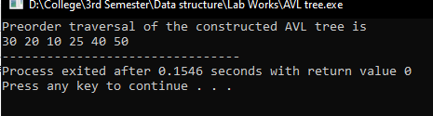Output:-

Lab 5

4.Implementation of Merge sort

Code:-

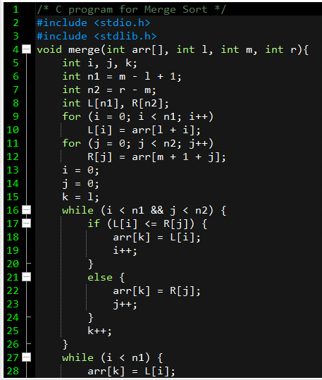

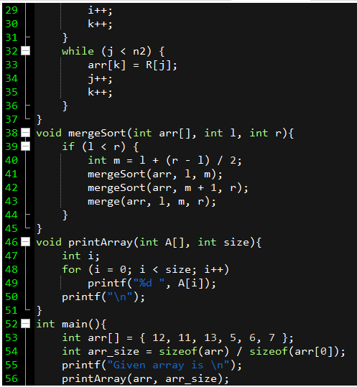

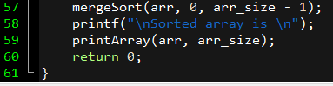

Output:-

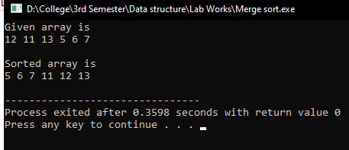

Lab 5

5. Implementation of heap

Code:-

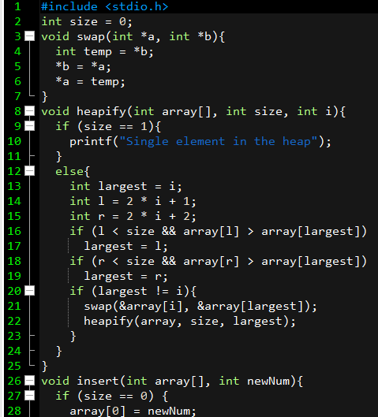

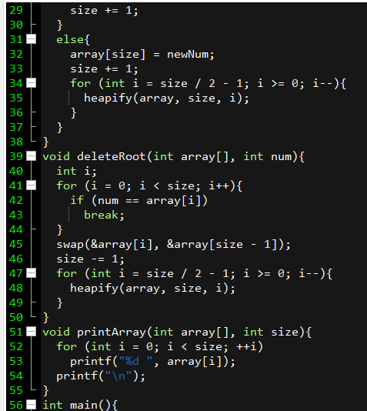

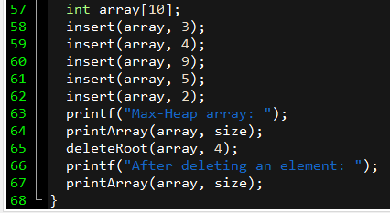

Output:-

